**To Write A Program To Find The Factorial Of A Number Using Procedures.**

**Aim:** To find a gcd between two numbers in mixed language (C and Tasm) programs

**Prerequisite**: TASM assembler

**Theory:**

If the Given Number is a 16-bit number, the AX register is automatically used as the second parameter and the product is stored in the DX:AX register pair. This means that the DX register holds the high part and the AX register holds the low part of a 32-bit number. In an 8086 microprocessor, users have direct instruction (MUL) to multiply two numbers, so we don’t have to add multiplicand by Multiplier times like in 8085.

**Algorithm :**

1. Start
2. Load the data into register B
3. To start multiplication set D to 01H
4. Jump to step 8
5. Decrements B to multiply previous number
6. Jump to step 4 till value of B>0
7. Take memory pointer to next location and store result
8. Load E with contents of B and clear accumulator
9. Repeatedly add contents of D to accumulator E times
10. Store accumulator content to D
11. Go to step 5
12. Stop.

**Code :**

DATA SEGMENT

NUM1 DW 05H

RESULT DW ?

DATA ENDS

MY SEGMENT

FACT PROC FAR

MUL CX

RET

ENDP

MY ENDS

CODE SEGMENT

START:

ASSUME CS:CODE , DS:DATA

MOV AX,DATA

MOV DS,AX

MOV CX,NUM1

MOV AX,0001H

UP : CALL FACT

LOOP UP

MOV RESULT,AX

MOV AH,4CH

INT 21H

CODE ENDS

END START

**Output:**

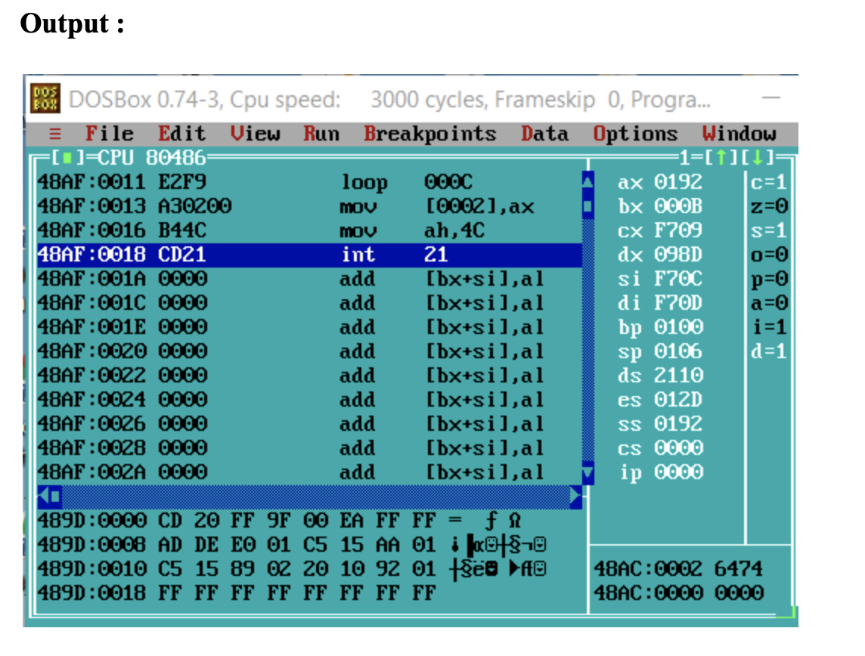

**Conclusion :**

From the above experiment we are really able to find the factorial in the assembly program. We are also able to learn about how we can use procedures in an assembly program. Just we need to check in the debugger where we can easily see the changes how the program works step by step just by clicking fn + F7. We can see the changes in the registers at the end.